Week 5 - Review & Simulated Competition

Part 1 - Computing Basics (11 points)
Name 3 parts of a computer (things you would find inside a computer)

____________________________________

____________________________________

____________________________________

Name 3 examples of computer peripherals (things you would attach to a computer)

____________________________________

____________________________________

____________________________________

Name 3 computing devices you can find at home or at school (note they might not all be “computers”)

____________________________________

____________________________________

____________________________________

What is an algorithm?

- A programming language, similar to Python, that converts normal sentences into binary code
- A procedure that solves a type of problem through a series of steps
- A diagram that uses shapes and arrows to show a series decision steps leading to a set of outcomes
- A really funky beat played at dance clubs for single-celled organisms

Name a programming language

_______________________

Part 2 - Theory (20 points)

The country of Weirdcoinistan has four coins with the following characteristics

Coin | Weight | Shape | Color | Value
 | 4 g | Circle | Gold | 13¢
 | 4 g | Hexagon | Gold | 8¢
 | 3 g | Hexagon | Gold | 5¢
 | 4 g | Circle | Silver | 3¢

Coinstar, LLC wants to expand their operations to Weirdcoinistan and need to build a coin sorting machine that can sort these coins into different bins. The machines can have 3 sensors: one for weight, one for color, and one for shape.

On the next page, draw a flowchart to show how the Coinstar Wierdcoinistan machines will use their sensors to sort coins into their different bins. Each decision step (diamond) should only have two options (arrows) coming out of it: YES and NO.

Get coin

Complete the following tables by filling in the missing values.

Decimal |  | Binary
5 | = | 101 (example)
9 | =
20 | =
65 | =

Binary |  | Decmial
101 (example) | = | 5
1100 | =
11111 | =
10000000 | =

Part 3 - Practical Computing (33 points)

Challenge 2: Crab Catch 3000
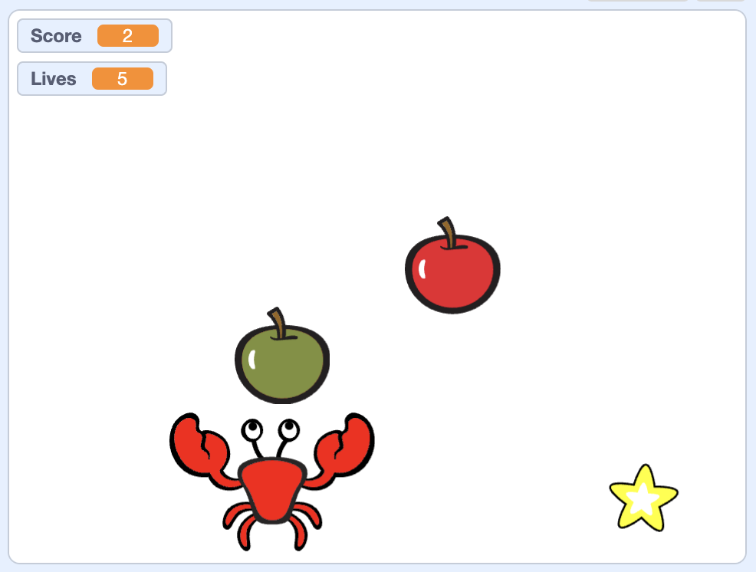

This game uses basically the same concepts as the first game, but is maybe slightly more challenging.

- The crab stays as the bottom of the screen and only moves right and left. It does not move off the screen.
- Stars and both kinds of apples fall from the top of the screen. They start at random positions along the top and fall straight down.
- The red apples fall slowest, green apples a bit faster, and stars fastest of all.
- Red apples fall continuously–there is always one on the screen. As soon as one is caught by the crab or hits the bottom of the screen a new one starts to fall from the top of the screen.
- Green apples fall continuously, but with a pause. When a green apple is caught or reaches the bottom there is a 1-5 second pause before the next green apple starts falling.
- Stars fall continuously, but with a pause. When a star is caught or reaches the bottom there is a 3-8 second pause before the next star starts falling.
- Caught red apples increase the score by 1.
- Caught green apples reduce the score by 1.
- Caught stars increase the score by 5.
- Every time a red apple is NOT caught, the player loses one life. When the user has no lives left the game is over.
- When the game is over, all crabs, apples, and stars should disappear and the background should change to say “Game Over” (or something that means the same thing).
- When the game starts, the crab is in the middle, there are no falling things (they start falling right after), the score is 0, and the player has 5 lives.

